Scenario: checking uploadfiles
Step: And the user waits for "2" seconds - PASS
Step: And the user waits for "2" seconds - PASS
Step: And the web application URL is launched in a NewWindow - PASS

Step: And the user waits for "5" seconds - PASS
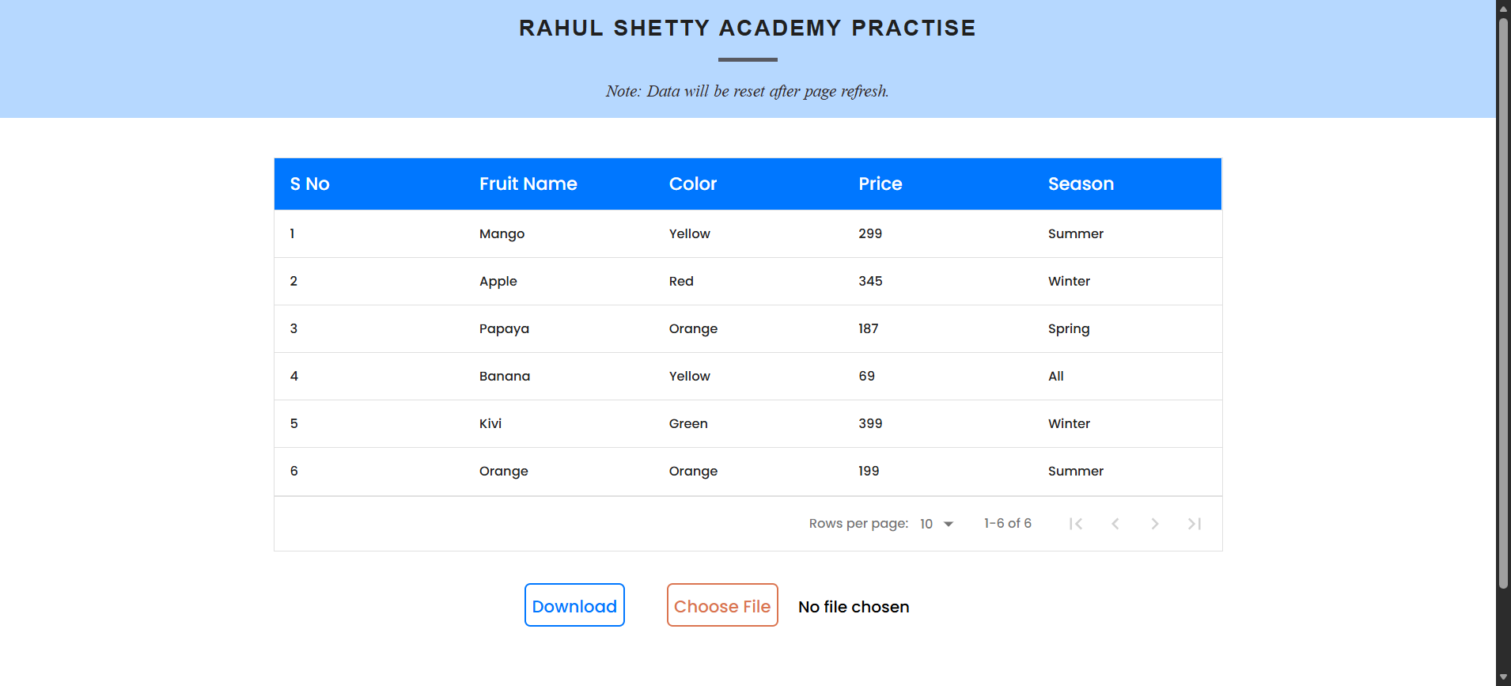
Step: User uploads file "\\Downloads\\download.xlsx" into "Choosefile" in "WHPage" page - PASS
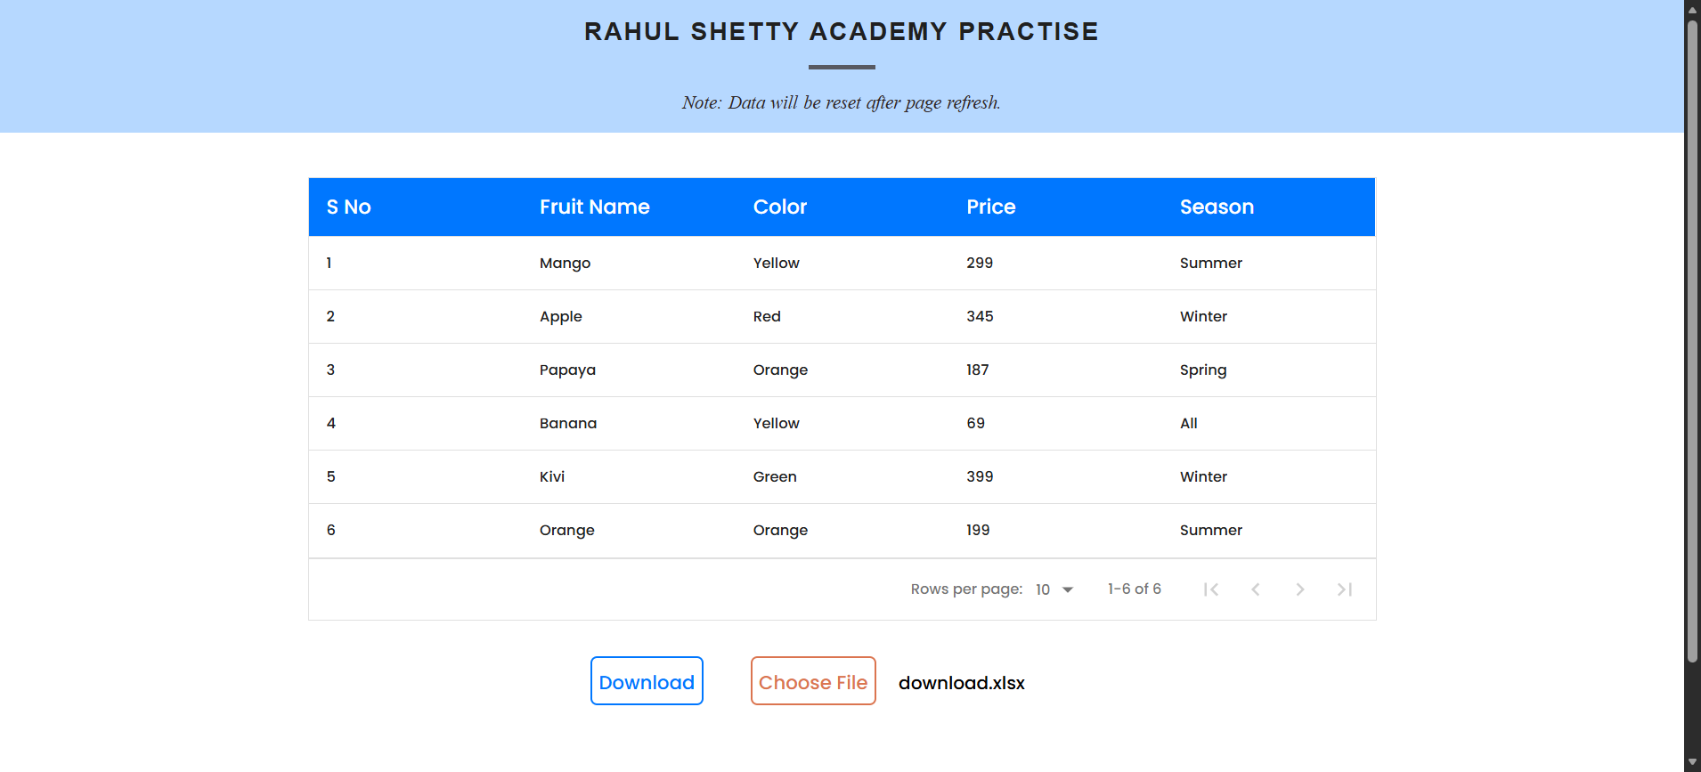
Step: And the user Get the text from"invisibletext" in "WHPage" page - PASS
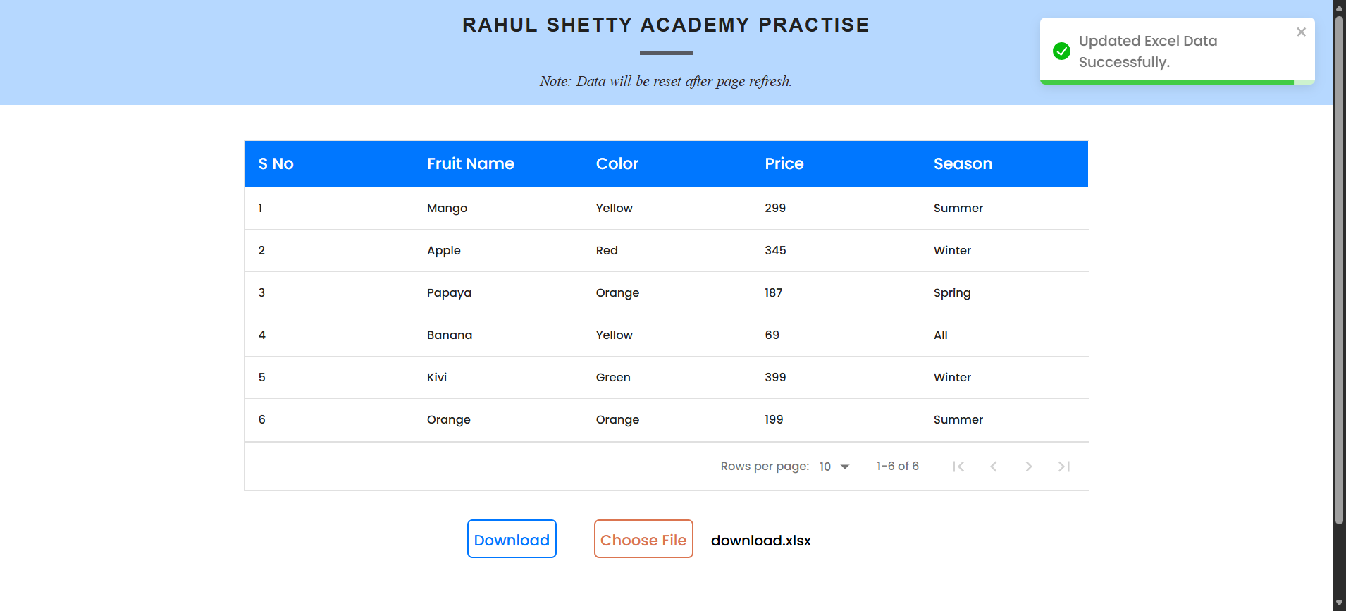
Step: And the user waits for "2" seconds - PASS
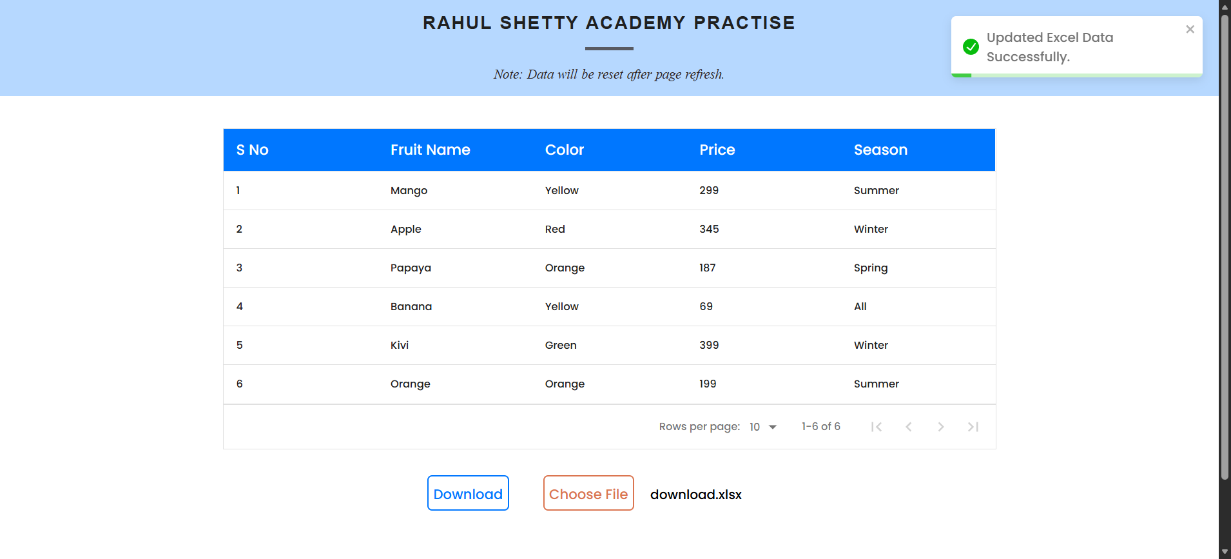
Execution Summary:
Total Steps: 7
Passed: 7
Failed: 0

